SOFTWARE PROPOSAL LoT MANGEMENT SYSTEM

GROUP 3 MEMBERS

Brett J. Davis

Thomas Kerley

Jasmine Irvin

Joshua Puetz

Contributions

Brett J. Davis 25%

Thomas Kerley 25%

Jasmine Irvin 25%

Joshua Puetz 25%

#### Parking Woes

A customer came to your dealership to test drive a dream car found on your website. Your salesperson pulls up the vehicle’s details and goes to the lot to find the car; however, it took too long searching. When your salesperson finally returns, the customer had already left in frustration. You just lost a sale.

You have a few deliveries of new cars coming in the next week. Do you have enough parking spaces in the lot? Can you sell enough cars in between deliveries to maximize your available inventory?

Do you have an offsite lot that you need to track which cars are there without being on site? Do you wish you could integrate technology to confirm if and where the vehicle is on the premises?

#### There are Solutions

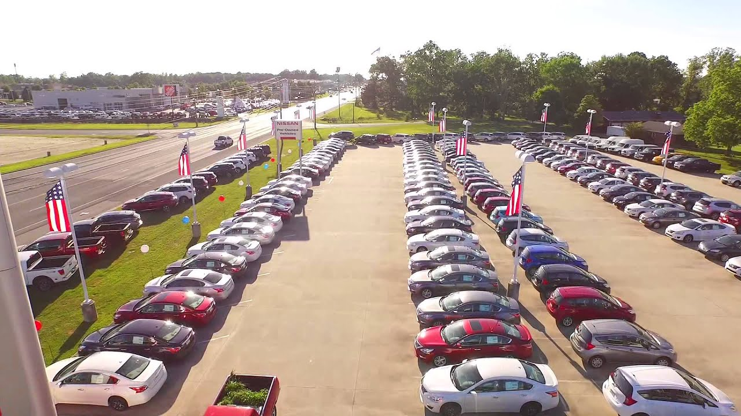With our software solutions, you can easily solve these problems. We offer inventory management solutions that can assist in tracking your vehicle inventory. By using our software interface showing where each vehicle is located, your employees can spend less time hunting for vehicles and further use the interface coordinate where to park them. Detailing and maintenance by the staff could be improved once employees are not wasting time searching for a needle in a haystack at the dealership. Tracking which vehicle spends more time on the lot can assist in sales decisions. If your dealership contains a prominent vehicle display parking space, our software solutions can provide insight to which vehicle was on display and correlate it to sales volume. By integrating our solution with your existing systems, you can track how many miles the average car is used to test drive. These tracked miles can be used to provide your accounting team with information to help with your bottom line.

#### Use Cases

*Finding a car for a test drive/do maintenance*:   
   
 Employee uses the license plate or other uniquely identifying information such as the VIN number to search for the desired car in our software. After receiving the location information, the employee walks straight to the car's location, retrieves it, and delivers it to the customer. After the test drive, the odometer is recorded into the software and the software tracks how much mileage the test drive consumed.   
  
*Reporting information on a specific car:*  
  
 An office employee would like to see movement and test drive statistics about a specific car. The employee can log onto our application, query the car by a uniquely identifying characteristic and view its history of movement throughout the lot and the reasons for doing so. The employee can also view test drive frequency and amount of mileage added to the odometer because of it.

*Detect anomalous car movement:*   
  
 If a vehicle is inaccurate in the system or is moved without reason or documentation, further investigation can be done.

#### Proposed Treatment

We offer various solutions and processes that can be deployed in staged releases. Our process starts with an investigation of your existing dealership services to provide design documentation of what is existing, discovery of any improvements to the existing system, a parking automation integration, and further features as requested or that we recommend. This allows technicians and staff time to become familiar with the new systems and provide feedback as the systems are being developed.

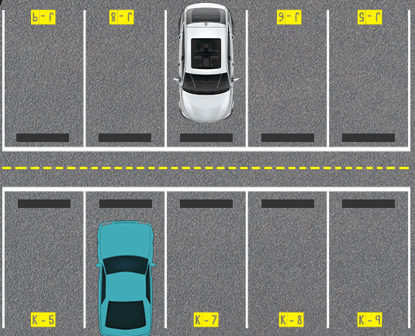**Step 1:** Our process starts with an investigation of your existing dealership. During this process, we will gather information about your current inventory management system and your parking lots and configurations. For example, for each lot used by your dealership, we will document its location, layout, and capacity. We will assign each parking location a unique number. We may further suggest optimizations of your parking lots to increase capacity and improve sales.

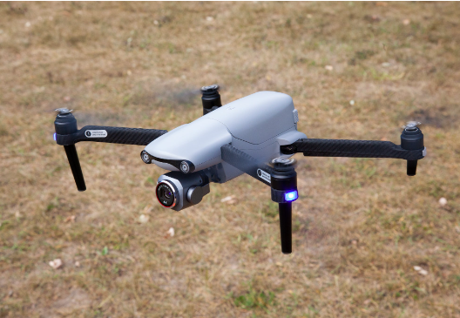**Step 2:** Next, our team will determine the technology best suited for your dealership. Various technologies exist to determine vehicle location, including cameras, RFID tags, and in-ground sensors.

Drones equipped with sensing technology may be used to determine the locations of vehicles. For example, a drone may be programmed to fly over your lot along a predetermined path several times a day and capture vehicle location information. This information is then transmitted to our cloud-based servers.



**Step 3:** Once we have confirmed which location technology is best suited for your dealership, our developers will roll up their sleeves and get to work. Our developers will develop a software solution adhering to the highest standards of computer programming.



**Step 4:** The last step is deployment. Our team will ensure a smooth transition to the new software. We will have our personnel on-site during the initial deployment. We will provide virtual training to your employees through online videos.

We also provide 24-hour customer service support to address any problems that may arise.

#### Deliverables

Our team will provide parking automation software that will have a user interface showing the status of the parking spaces and which car(s) are in them.

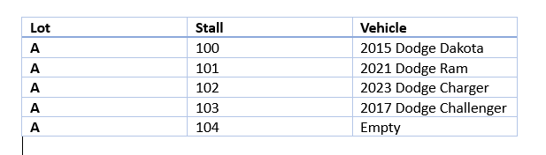

Our system can also provide parking space assignments for any new cars using various qualifiers, such as EV requirements or vehicle sizes. After our investigation we can provide recommendations or further products, such as a mileage tracker, test drive count, vehicle turnover rate, and other sales metrics. Often requested is a sensed updater system at each parking space, this often is accomplished by a sensor suite.

In addition, you will receive documentation which can include, but is not limited to, a software documentation regarding your data and programming structure; existing and new IT equipment maps to facilitate the automation systems, any research into current studies and trends, and various other desired reports. These reports can be correlated with your sales and accounting teams to help improve your bottom line. Further, the maps and documentation will provide support for any future system designs that are discovered through the process.

#### Meet the Team

We are a four-person team that has collectively over 20 years of experience, each with various backgrounds, to provide versatile solutions to any parking woes. Please visit our website at:

https://zippyauto1.herokuapp.com/

* Brett Davis
  + Back-end Lead and Registered Attorney
    - [bjdavis12@mail.fhsu.edu](mailto:bjdavis12@mail.fhsu.edu)
* Jasmine Irvin
  + Python & Java Backend Systems Expert as well as Support Professional
    - [jcirvin2@mail.fhsu.edu](mailto:jcirvin2@mail.fhsu.edu)
* Joshua Puetz
  + IT Server-side Expert and REST API Manager
    - [japuetz@mail.fhsu.edu](mailto:japuetz@mail.fhsu.edu)
* Thomas Kerley
  + Project coordinator who has a background in Python programming and Architectural engineering.
    - [tmkerley@mail.fhsu.edu](mailto:tmkerley@mail.fhsu.edu)

#### Conclusion

In conclusion, the parking woes faced by your dealership can be effectively addressed with our software solutions. By implementing our inventory management system, you can significantly reduce the time spent searching for vehicles and optimize the utilization of your available parking spaces. Our software interface will provide real-time tracking of vehicle locations, allowing your employees to coordinate parking and sales decisions more efficiently. Additionally, integrating our solution with your existing systems will enable you to track important metrics such as test drive mileage and vehicle turnover rate, providing valuable insights for your sales and accounting teams.

Our proposed treatment involves a comprehensive process that includes an investigation of your dealership, determination of the best technology for your needs, development of a high-quality software solution, and smooth deployment with training and customer support. The deliverables include parking automation software with a user-friendly interface, documentation on data and programming structure, IT equipment maps, research on current studies and trends, and other desired reports.

By leveraging our software solutions, you can overcome the parking challenges and enhance your dealership's efficiency and profitability.